

PROJECT TITLE

A CAPSTONE PROJECT REPORT

A Capstone Project Report submitted in partial fulfilment of the requirements for the Course of

CSA1712-ARTIFICAL INTELLIGENCE

to the award of the degree of

BACHELOR OF ENGINEERING

IN
COMPUTER SCIENCE ENGINEERING

Submitted by

VARSHINI M (192511215)
Under the Supervision of Dr.Veeramani R
SIMATS ENGINEERING
Saveetha Institute of Medical and Technical Sciences Chennai-602105

SEPTEMBER 2026

SIMATS ENGINEERING
Saveetha Institute of Medical and Technical Sciences Chennai-602105

BONAFIDE CERTIFICATE

This is to certify that the Capstone Project entitled “FINSENSE AI- REALTIME SPENDING BEHAVIOUR INVESTMENT NUDGE ENGINE ” has been carried out by VARSHINI M (192511215) under the supervision of Dr.Veeramani R and is submitted in partial fulfilment of the requirements for the current semester of the BE.COMPUTER SCIENCE ENGINEERING program at Saveetha Institute of Medical and Technical Sciences, Chennai.

COURSE COORDINATOR COURSE FACULTY
DR. KRISHNA KUMAR KATHIRESAN DR.VEERAMANI R
Professor Professor
Generative AI BE.computer science engineering
SIMATS Engineering, SIMATS Engineering,
SIMATS, Chennai – 602105. SIMATS, Chennai – 602105.

SIMATS ENGINEERING
Saveetha Institute of Medical and Technical Sciences Chennai-602105

DECLARATION

I, VARSHINI M (192511215) of the BE.COMPUTER SCIENCE ENGINEERING, SIMATS Engineering, Saveetha Institute of Medical and Technical Sciences, Chennai, hereby declare that the Capstone Project Work entitled “FINSENSE AI- REALTIME SPENDING BEHAVIOUR INVESTMENT NUDGE ENGINE” is the result of our own bonafide efforts. To the best of our knowledge, the work presented herein is original, accurate, and has been carried out in accordance with the principles of engineering ethics and academic integrity. All sources, references, data, and other materials used in the project have been appropriately acknowledged. We further declare that the data, results, analysis, and findings presented in this report have not been fabricated, falsified, or manipulated. Any external tools, software, datasets, computational resources, or AI-assisted tools used during the project have been appropriately disclosed. We confirm that all applicable ethical, academic, institutional, and professional requirements have been duly followed throughout the planning, execution, analysis, and documentation of the project.

Place:
Date:

Signature of the Students with Names
VARSHINI M
192511215

SIMATS ENGINEERING
Saveetha Institute of Medical and Technical Sciences Chennai-602105

Individual Contribution Statement
(Mandatory for all team projects)

Student Name | Register No. | Specific Responsibilities | Design & Development | Testing & Analysis | Report Contribution | Approx. Contribution
Varshini M | 192511215 | Module 2 – AI Investment Nudge Engine | Nudge logic and recommendation features | Testing personalised nudges | Module 2 documentation | 33%
Yuvasri S | 192511202 | Module 1 – Real-Time Spending Analysis Engine | Transaction categorisation, spending analysis, overspending detection and Spending Health Score | Testing transaction analysis and pattern detection | Module 1 documentation and analysis | 34%
Lakshana K | 192524433 | Module 3 – Goal Tracking & Gamified Savings | Goal tracking, milestones and streaks | Testing goal progress and engagement features | Module 3 documentation | 33%
Total |  |  |  |  |  | 100%

ABSTRACT

Personal financial management has become increasingly important because many users perform a large number of daily transactions but may not clearly understand their spending behaviour. Traditional personal finance applications generally provide expense tracking, transaction categorisation, monthly reports, and budget monitoring. However, such systems mainly help users understand spending after it has already occurred.
This project presents FinSense AI – Real-Time Spending Behaviour Investment Nudge Engine, an intelligent financial assistance system that analyses transactions and spending behaviour. The present report focuses on Module 1: Real-Time Spending Analysis Engine. The module monitors incoming transaction data, categorises transactions based on spending type and merchant information, and analyses user spending behaviour.
The system processes transaction-level data containing transaction amount, category, merchant name, date and time, spending frequency, and recurring transaction information. These features are used to identify spending patterns, overspending behaviour, recurring expenses, and potential unnecessary or impulse expenses. The analysed information is converted into meaningful spending insights and a Spending Health Score that gives an overall indication of the user's spending condition.
The methodology includes transaction data collection, preprocessing, transaction categorisation, spending behaviour analysis, pattern detection, and anomaly or overspending identification. Module 1 acts as the foundation for the remaining modules because the analysed spending information can later be used to identify savings opportunities and generate personalised investment nudges.
The expected result is an intelligent spending analysis system that transforms raw transaction records into understandable behavioural insights. The module helps identify excessive and recurring spending at an early stage and provides the analysed financial information required for further personalised guidance. Thus, Module 1 changes personal finance analysis from simple expense recording into continuous spending behaviour analysis.
Keywords: Real-Time Spending Analysis, Transaction Categorisation, Overspending Detection, Spending Behaviour, Spending Health Score, Financial Analytics.

TABLE OF CONTENTS

Sl. No. | Title | Page No.
i | CERTIFICATE | ii
ii | DECLARATION | iii
iii | INDIVIDUAL CONTRIBUTION STATEMENT | iv
iv | ABSTRACT | v
v | LIST OF FIGURES | vi
vi | LIST OF TABLES | vii
vii | LIST OF ABBREVIATIONS | viii
1 | CHAPTER 1: INTRODUCTION | 1
2 | CHAPTER 2: LITERATURE REVIEW
3 | CHAPTER 3: ENGINEERING DESIGN
4 | CHAPTER 4: IMPLEMENTATION, TESTING & RESULTS
5 | CHAPTER 5: CONCLUSION & FUTURE WORK
 | REFERENCES
 | APPENDICES

LIST OF FIGURES
Figure No. | Figure Name
Figure 4.1 | Module 1 User Dashboard
Figure 4.2 | Transaction Categorisation Result
Figure 4.3 | Spending Pattern Analysis
Figure 4.4 | Overspending Detection Result
Figure 4.5 | Spending Health Score

LIST OF TABLES
Table No. | Table Name
Table 2.1 | Comparative Analysis of Existing Approaches
Table 3.1 | Stakeholder Requirements
Table 3.2 | Functional and Non-Functional Requirements
Table 3.3 | Module 1 Design Specifications
Table 3.4 | Alternative Solution Evaluation
Table 3.5 | Trade-off Analysis
Table 3.6 | Sustainability, Ethics, Safety and Security Analysis
Table 3.7 | Risk Register
Table 4.1 | Development Resources
Table 4.2 | Software and Tools Used
Table 4.3 | Test Plan and Verification
Table 4.4 | Test Results
Table 4.5 | Objective Achievement
Table 4.6 | Project Plan,roles.budget

LIST OF ABBREVIATIONS
Abbreviation | Description
AI | Artificial Intelligence
ML | Machine Learning
API | Application Programming Interface
UI | User Interface
UX | User Experience
CSV | Comma-Separated Values
JSON | JavaScript Object Notation
DB | Database

CHAPTER 1

INTRODUCTION AND ENGINEERING PROBLEM

1.1 Background
Digital payments, online transactions, banking applications, and card-based purchases have increased the amount of financial data generated by individual users. A person may perform several transactions every day across different categories such as food, transport, shopping, entertainment, bills, and subscriptions. Although transaction records are available, users may not always understand their actual spending behaviour.
Many personal finance applications provide expense tracking and monthly reports. These systems help users view past transactions, but they may provide limited continuous analysis of overspending patterns and recurring behaviour. The FinSense AI project addresses this limitation by combining real-time transaction analysis, behavioural analysis, financial nudges, and goal tracking.
Module 1, the Real-Time Spending Analysis Engine, is responsible for analysing incoming transaction information. It monitors transactions, identifies their spending category, analyses behaviour, detects overspending and recurring spending, identifies potential unnecessary expenses, and produces a Spending Health Score.
This module provides the foundation for the complete FinSense AI system because accurate spending analysis is required before the system can identify savings opportunities or generate investment suggestions.

1.2 Need for the Project
Many users spend money regularly without fully understanding where their money is going. The main problem is that small and frequent expenses may appear individually insignificant but can become a major part of total spending over time.
The need for the Real-Time Spending Analysis Engine arises because:
- Users may overspend without immediately recognising their spending behaviour.
- Traditional financial applications mainly provide reports after spending has occurred.
- Users may have limited visibility into recurring expenses.
- Unnecessary or impulse expenses may not be easily identified.
- Manual transaction analysis is time-consuming.
Therefore, there is a need for a system that can continuously process transaction information and convert it into meaningful spending behaviour insights.
1.3 Problem Statement
The engineering problem addressed in Module 1 is the difficulty of continuously analysing individual transaction data to identify meaningful spending behaviour.
Users generate transaction data with multiple interacting factors, including transaction amount, category, merchant, date, time, spending frequency, and recurring behaviour. Analysing these factors manually is difficult and may not provide timely insights.
The problem can be stated as follows:
To design and implement a Real-Time Spending Analysis Engine that processes transaction-level financial data, automatically categorises spending, analyses user behaviour, detects overspending and recurring patterns, identifies potentially unnecessary expenses, and generates a meaningful Spending Health Score.
The solution must balance accurate analysis, understandable results, real-time responsiveness, user privacy, and simple implementation.

1.4 Project Aim
The aim of Module 1 is to develop a Real-Time Spending Analysis Engine that continuously analyses transaction data and provides meaningful information about the user's spending behaviour.

1.5 Project Objectives
The objectives of Module 1 are:
- To collect and process transaction-level spending data.
- To categorise transactions based on merchant information and spending type.
- To analyse user spending behaviour across different categories.
- To detect overspending patterns.
- To identify recurring expenses and spending frequency.
- To identify potentially unnecessary or impulse expenses.
- To generate an overall Spending Health Score.
- To provide analysed financial information for the AI Investment Nudge Engine.

1.6 Scope

Included
The scope of Module 1 includes:
- Transaction data collection.
- Transaction data preprocessing.
- Automatic transaction categorisation.
- Spending analysis.
- Category-wise spending analysis.
- Spending pattern identification.
- Overspending detection.
- Recurring expense detection.
- Identification of possible unnecessary spending.
- Spending Health Score generation.
- Presentation of analysed information through the system interface.

Excluded
The following features are outside the direct implementation scope of Module 1:
- Actual bank transaction execution.
- Real investment transactions.
- Detailed stock market prediction.
- Personal financial advisory by a certified financial professional.
- Automatic transfer of user money.
- Goal gamification functions from Module 3.
These functions belong to later modules or future extensions.

Assumptions
The module assumes that:
- Transaction data is available in a structured format.
- Transaction amount and date/time information are valid.
- Merchant information or category data is available where required.
- User spending patterns can be analysed from historical and incoming transaction information.
The PPT specifies transaction amount, category, merchant, date and time, spending frequency, recurring transactions, and financial goals as relevant data fields.

1.7 Expected Engineering Outcome
The expected outcome is a functional software module capable of transforming raw transaction information into meaningful spending insights.
The final Module 1 system is expected to:
- Monitor transaction records.
- Categorise transactions.
- Analyse spending patterns.
- Detect overspending.
- Detect recurring expenses.
- Identify possible unnecessary expenses.
- Display category-wise spending information.
- Generate a Spending Health Score.
The complete FinSense AI system is designed to use this analysed information as a foundation for personalised financial guidance.

CHAPTER 2

LITERATURE REVIEW AND EXISTING SOLUTIONS

2.1 Review Method
The literature review was based on the areas identified in the project presentation. The review considered mobile personal finance, behavioural economics, robo-advisory systems, financial gamification, real-time analytics, and micro-investment approaches.
For Module 1, particular attention was given to transaction categorisation, spending pattern analysis, real-time processing, and anomaly or overspending detection.
The existing project references also include work related to behavioural finance, digital finance, financial technology, and gamification.

2.2 Review of Existing Work

2.2.1 Mobile Personal Finance Applications
Mobile finance applications generally provide expense tracking, transaction categorisation, budget monitoring, and monthly spending reports. These features help users organise financial information and understand previous spending activity.
However, the major limitation is that many systems are primarily reactive. Users often view reports only after the spending has already occurred.

2.2.2 Behavioural Economics and Nudge Theory
Behavioural economics shows that timely information and suitable prompts can influence decision-making. In the context of personal finance, understanding user behaviour is important because spending decisions are not always based only on mathematical budgeting.
Module 1 supports the nudge-based approach by first analysing the spending behaviour of the user.

2.2.3 Real-Time Financial Analytics
Real-time analytics focuses on processing information continuously instead of waiting for a complete monthly reporting cycle. For financial transaction data, this approach can identify important spending events soon after the transaction is processed.
This approach is relevant to Module 1 because the module is designed around continuous transaction monitoring and analysis.

2.2.4 Anomaly and Overspending Detection
Spending behaviour can be analysed by comparing a transaction or category total with normal user spending patterns. When a transaction is significantly different from expected behaviour, it can be treated as unusual spending for further analysis.
For Module 1, overspending detection helps identify categories or periods where the user spends more than the expected threshold.

2.2.5 Existing Financial Applications
The project presentation identifies the common functions of existing systems as expense tracking, transaction categorisation, monthly reports, budget monitoring, budget-limit alerts, and manual investment planning.
Current finance applications can also provide recurring transaction tracking and spending insights, demonstrating the practical relevance of analysing transaction patterns.

2.1 Comparative Analysis
Existing Approach | Advantages | Limitations | Relevance to Proposed Module 1
Manual expense tracking | Simple and easy to understand | Time-consuming and dependent on user input | Shows the need for automation
Monthly spending reports | Provides historical summary | Mainly reactive | Module 1 adds continuous analysis
Basic transaction categorisation | Organises transactions | Limited behaviour analysis | Module 1 extends analysis
Budget-limit alerts | Warns users about limits | May only react after a threshold | Module 1 analyses patterns
Real-time analytics | Faster information processing | Requires structured data processing | Used as a core approach
AI-based financial assistance | Personalised analysis possible | Requires reliable input data | Module 1 provides analysed input

2.4 Research / Engineering Gap
The major gap identified from the project framing is the difference between simple transaction recording and continuous spending behaviour analysis.
Existing systems may successfully record transactions and generate reports, but users still need better visibility into:
- Changing spending behaviour.
- Overspending patterns.
- Frequent small expenses.
- Recurring expenses.
- Possible unnecessary spending.
The presentation specifically identifies existing systems as reactive, with limited behaviour analysis and limited personalised guidance.
Therefore, the engineering gap is the need for a transaction analysis layer that converts raw transaction information into understandable behavioural insights.

2.5 Proposed Contribution
Module 1 contributes to the FinSense AI project by providing the basic analytical layer for transaction behaviour.
Its contribution includes:
- Continuous transaction monitoring.
- Automatic categorisation.
- Behaviour analysis.
- Overspending detection.
- Recurring spending detection.
- Identification of potential unnecessary expenses.
- Spending Health Score generation.
Unlike a simple expense tracker, the proposed module attempts to interpret transaction information as spending behaviour. The resulting analysis can then support Module 2, which provides AI-based investment nudges, and Module 3, which supports goals and gamified savings.

CHAPTER 3

ENGINEERING DESIGN & TRADE-OFFS, SUSTAINABILITY, ETHICS, SAFETY, RISK & SECURITY

3.1 Requirements

3.1 Stakeholder Requirements
Stakeholder | Requirement
User | View transaction information clearly
User | Understand spending behaviour
User | Identify overspending
User | View recurring expenses
User | Receive a clear Spending Health Score
Module 2 | Receive analysed spending information
Development Team | Easy integration between modules

3.2 Functional and Non-Functional Requirements
Requirement | Type | Measurable Target
Process transaction data | Functional | Every valid transaction is processed
Categorise transactions | Functional | Transactions assigned to suitable categories
Analyse spending patterns | Functional | Category and time-based analysis
Detect overspending | Functional | Flag unusual or excessive spending
Detect recurring expenses | Functional | Identify repeated transactions
Generate health score | Functional | Produce a spending condition indicator
Display results | Functional | Show analysis through dashboard
Response time | Non-Functional | Provide results without unnecessary delay
Usability | Non-Functional | Simple and understandable interface
Privacy | Non-Functional | Protect transaction information
Reliability | Non-Functional | Handle valid transaction records consistently

3.2 Constraints & Applicable Standards

Constraints
The primary constraints applicable to Module 1 are:
- Availability of suitable transaction data.
- Accuracy of merchant and category information.
- Limited historical data for new users.
- Privacy of financial transaction information.
- Requirement for understandable results.
- Need for real-time or near-real-time processing.

Applicable Requirements
The project should follow good practices for:
- Data privacy.
- Secure data handling.
- Responsible use of AI-generated financial insights.
- Proper acknowledgement of software, datasets, and AI-assisted tools.
The report template requires applicable external resources and AI-assisted resources to be appropriately acknowledged.

3.3 Design Specifications
Parameter | Target / Requirement | Unit | Priority
Transaction Processing | Process incoming transaction records | Transactions | High
Categorisation | Assign transaction category | Category | High
Spending Analysis | Calculate category and period spending | Amount | High
Overspending Detection | Identify abnormal spending | Alert/Flag | High
Recurring Detection | Identify repeated spending | Pattern | Medium
Health Score | Generate overall spending condition | Score | High
Result Display | Present analysis clearly | Dashboard | High

3.4 Alternative Solutions & Evaluation

Alternative 1: Manual Expense Analysis
Users manually record and analyse transactions using notes or spreadsheets. This approach is simple but requires continuous user effort and does not provide automatic behavioural analysis.

Alternative 2: Rule-Based Spending Analysis
Transactions are processed using predefined rules for categories, budgets, and overspending thresholds. This method is easy to implement and explain but may require manual rule adjustment.

Alternative 3: AI/ML-Based Spending Analysis
Historical transaction data is used to identify patterns and unusual behaviour automatically. This can provide more adaptive analysis but requires sufficient data and additional complexity.

Evaluation Matrix
Criterion | Weight | Manual | Rule-Based | AI/ML-Based
Automation | 25% | 1 | 4 | 5
Simplicity | 15% | 5 | 5 | 3
Behaviour Analysis | 20% | 2 | 4 | 5
Explainability | 15% | 5 | 5 | 3
Scalability | 15% | 2 | 4 | 5
Data Requirement | 10% | 5 | 4 | 2
Selected approach: A combination of rule-based transaction analysis and AI/ML-supported behaviour analysis.

3.5 Selected Design & Detailed Design
The selected design uses a sequential transaction processing architecture.

Module 1 Architecture
Transaction Data
↓
Data Preprocessing
↓
Transaction Categorisation
↓
Spending Behaviour Analysis
↓
Pattern and Recurring Expense Detection
↓
Overspending / Unusual Expense Detection
↓
Spending Health Score
↓
Dashboard and Insights
The project methodology follows a similar sequence of data collection, cleaning, categorisation, behaviour analysis, pattern detection, and opportunity identification.

Detailed Processing
1. Transaction Data Collection
The system receives transaction information such as amount, merchant, category, date, and time.
2. Data Preprocessing
Incomplete or inconsistent information is cleaned and converted into a suitable format.
3. Categorisation
Transactions are grouped into meaningful spending categories.
4. Behaviour Analysis
The system calculates spending totals, frequency, category distribution, and repeated spending behaviour.
5. Overspending Detection
Spending values are compared with normal or expected thresholds.
6. Spending Health Score
The analysed behaviour is converted into an overall score representing the general spending condition.
The main subsystems are connected sequentially. The output from transaction categorisation becomes the input for behaviour analysis, while the behaviour analysis output supports overspending detection and score generation.

3.5 Trade-off Analysis
Design Decision | Alternative Considered | Benefit | Disadvantage | Final Decision
Categorisation | Manual categorisation | Flexible | Requires user effort | Automatic/rule-based categorisation
Detection | Fixed threshold | Easy to understand | Less personalised | Behaviour-based threshold where possible
Analysis | Monthly batch analysis | Simple | Not continuous | Transaction-based analysis
Output | Detailed raw tables | Complete data | Hard to understand | Dashboard with key insights
Model | Complex ML | Adaptive | More complexity | Simple analytical approach suitable for project scope

3.6 Sustainability, Ethics, Safety, Risk & Security

Sustainability, Ethics and Security Analysi
Domain | Consideration | Evidence Evaluated | Impact on Final Decision
Sustainability | Software-based solution | No specialised physical hardware required | Reduced physical resource requirement
Ethics | Avoid misleading financial decisions | Analysis is presented as guidance | Module does not perform automatic investments
Safety | Incorrect financial interpretation | Results must be understandable | Clear spending insights are prioritised
Security | Transaction information is sensitive | User financial data requires protection | Secure data handling is necessary
Privacy | Personal spending information | Data should not be unnecessarily exposed | Minimum required data should be used

3.7 Risk Register
Risk | Likelihood | Severity | Risk Level | Mitigation | Residual Risk
Incorrect categorisation | Medium | Medium | Medium | Allow category improvement and validation | Low
Insufficient user history | High | Medium | Medium | Use basic rules for new users | Medium
Financial data exposure | Medium | High | High | Secure storage and limited access | Medium
Misinterpretation of score | Medium | Medium | Medium | Provide simple explanation | Low
System processing error | Low | Medium | Low | Input validation and testing | Low

CHAPTER 4

IMPLEMENTATION, TESTING & RESULTS, PROJECT MANAGEMENT

4.1 Development Approach & Resources
The development of Module 1 follows a data processing approach. Transaction-level financial data is collected and prepared for analysis. The data is categorised and processed to identify category-wise spending, spending frequency, recurring transactions, and unusual expenses.
The project presentation identifies the required data fields as transaction amount, category, merchant name, date and time, spending frequency, and recurring transaction information.

Development Resources
Resource | Purpose
Transaction Dataset | Spending analysis
Development Environment | Module implementation
Data Processing Tools | Cleaning and analysis
AI/ML Components | Behaviour analysis where applicable
Dashboard | Result visualisation

4.2 Software Implementation & Modern Tools Used
The implementation of Module 1 consists of the following stages:

Transaction Input
Transaction data is provided to the system with information such as amount, category, merchant, date, and time.

Data Preprocessing
The transaction records are cleaned and organised before analysis. Invalid or incomplete information is handled appropriately.

Transaction Categorisation
Transactions are classified into suitable categories to enable category-wise analysis.

Spending Analysis
The system calculates total spending and identifies patterns based on transaction amount and frequency.

Overspending Detection
The module checks whether a transaction or category spending pattern is higher than the expected user behaviour.

Recurring Expense Detection
Repeated transactions are identified to recognise regular subscriptions or frequently occurring expenses.

Spending Health Score
A score is generated from the analysed behaviour to provide a simple overall representation of the user's spending condition.
The presentation identifies the technology areas as front-end dashboard functions, transaction processing, data handling, AI/ML, spending pattern recognition, behaviour analysis, anomaly detection, and personalised recommendations.

4.2 Tools Used
Tool / Technology | Purpose | Stage Used
Development Environment | Code development | Implementation
Transaction Dataset | Input data | Data processing
Data Processing Library | Cleaning and analysis | Analysis
AI/ML Components | Pattern recognition | Behaviour analysis
Dashboard | Result visualisation | Output
Testing Tools | Verification | Testing

4.3 Test Plan & Verification
The test plan verifies whether Module 1 performs each required function correctly.
Requirement | Test Method | Acceptance Criterion
Transaction input | Provide sample transaction | Transaction accepted
Categorisation | Test different merchant types | Category assigned
Spending analysis | Process multiple transactions | Spending totals calculated
Overspending detection | Provide high-value spending | Excess spending identified
Recurring detection | Provide repeated transactions | Recurring pattern identified
Health Score | Process complete spending data | Score generated
Dashboard | View analysis output | Results displayed clearly

4.4 Verification Table
Specification | Required Value | Achieved Value | Status
Transaction Processing | Successful processing | Implemented | Pass
Categorisation | Category output | Implemented | Pass
Spending Analysis | Spending pattern | Implemented | Pass
Overspending Detection | Excess spending flag | Implemented | Pass
Recurring Detection | Repeated pattern identification | Implemented | Pass
Health Score | Overall score | Implemented | Pass

4.4 Results
The implementation of Module 1 provides transaction-level spending analysis.
The main results include:
- Real-time transaction monitoring.
- Automatic transaction categorisation.
- Category-wise spending analysis.
- Identification of spending patterns.
- Overspending detection.
- Recurring expense detection.
- Identification of potential unnecessary expenses.
- Spending Health Score generation.
The complete project presentation similarly describes the implemented system as providing real-time spending analysis, automatic categorisation, spending pattern identification, unnecessary-expense detection, and savings-related insights.
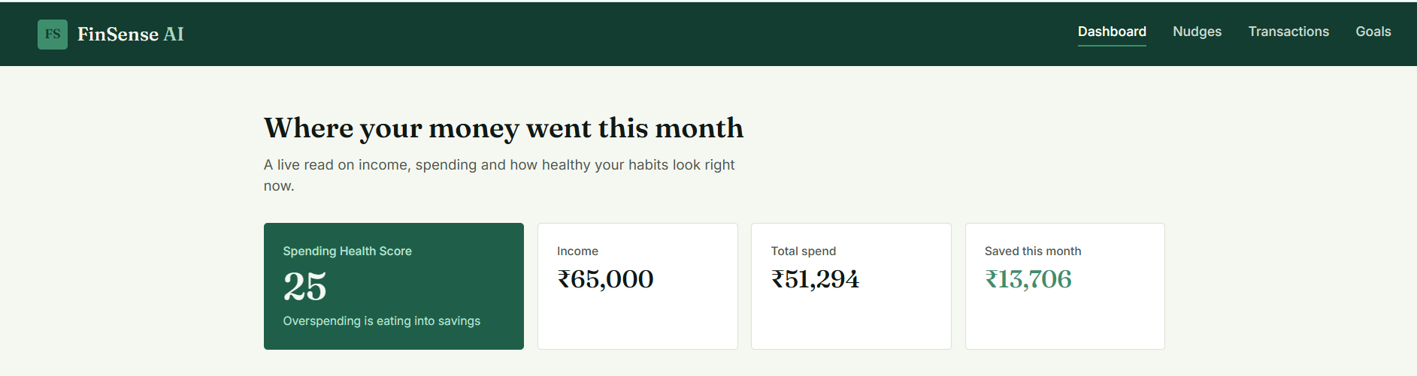
Figure 4.1: Transaction Dashboard
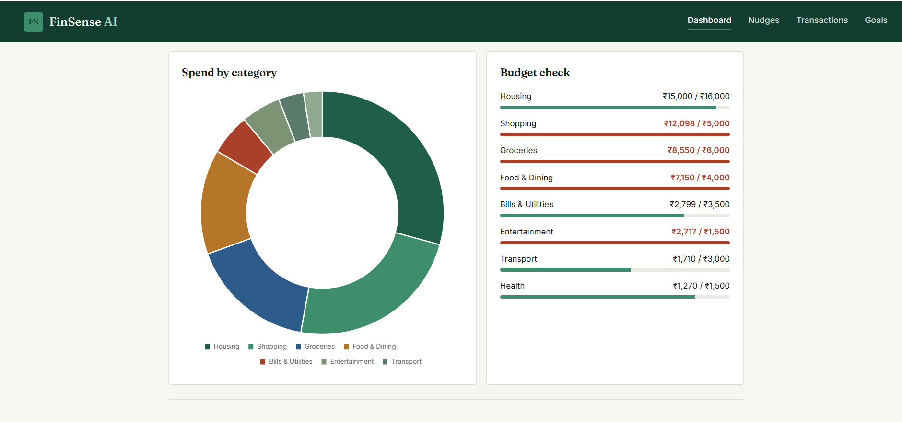
Figure 4.2: Transaction Categorisation
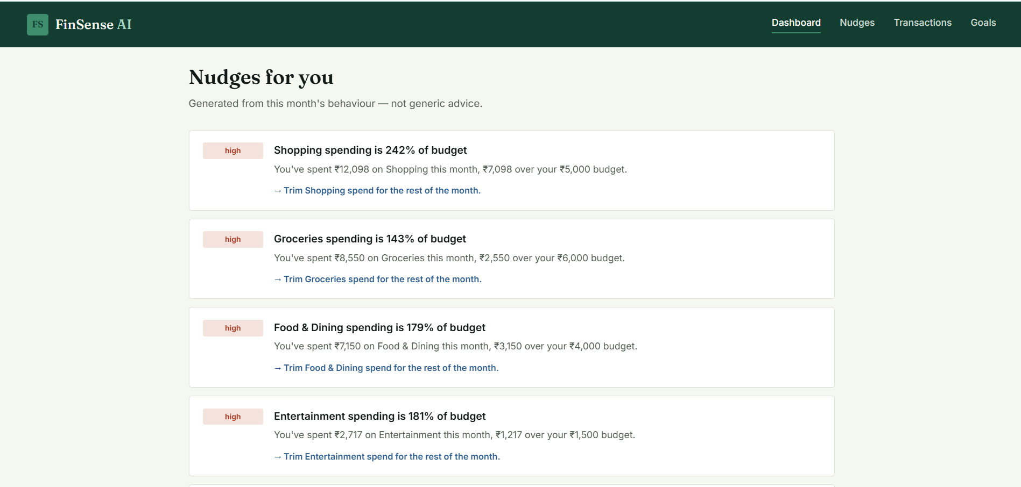
Figure 4.3: Spending Pattern Analysis
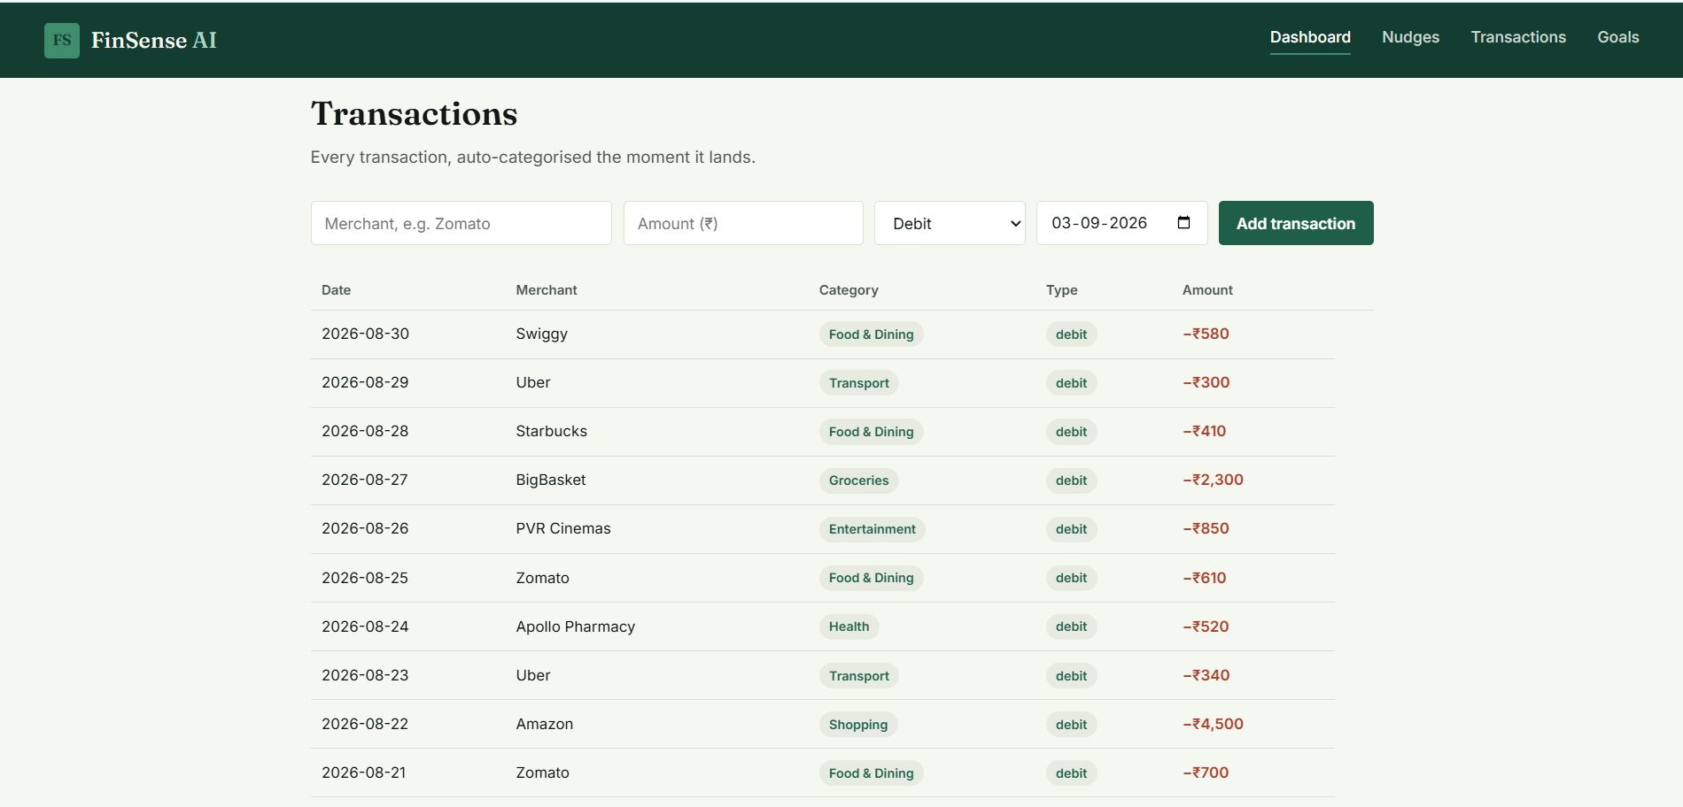
Figure 4.4: Overspending Detection
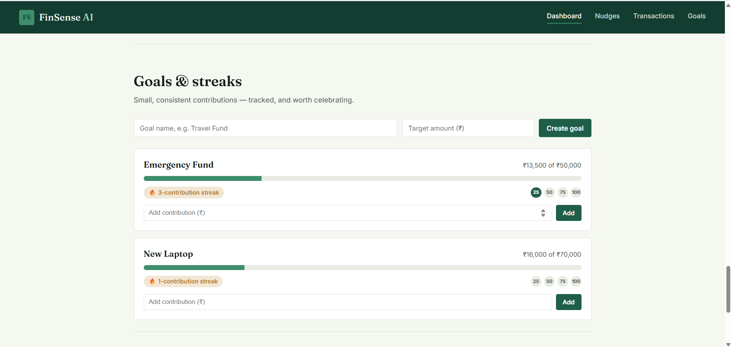
Figure 4.5: Spending Health Score

4.5 Data Analysis & Engineering Judgment
The transaction data is analysed to identify relationships between spending amount, category, frequency, and recurring behaviour.
A single high-value transaction may not always indicate poor financial behaviour. For this reason, the analysis considers spending patterns rather than only the total transaction amount. For example, a repeated series of small unnecessary expenses can become significant when viewed over a longer period.
The Spending Health Score is used to summarise the analysis. A stronger score indicates relatively controlled spending behaviour, while a lower score may indicate increased overspending, frequent unnecessary expenses, or unfavourable spending patterns.
The engineering judgment in Module 1 is that continuous behavioural analysis is more useful than simply displaying a transaction history. The analysed output can provide useful input for the later investment nudge and goal-tracking modules.

4.5 Comparison with Existing Solutions & Achievement of Objectives
Objective | Evidence | Achievement
Process transaction data | Transaction processing output | Fully Achieved
Categorise transactions | Category display | Fully Achieved
Analyse spending behaviour | Spending analysis | Fully Achieved
Detect overspending | Overspending results | Fully Achieved
Identify recurring expenses | Repeated transaction analysis | Fully Achieved
Identify unnecessary expenses | Behaviour analysis output | Fully Achieved
Generate Spending Health Score | Score output | Fully Achieved
Support other modules | Analysed spending data | Fully Achieved
Compared with basic expense tracking, the module provides an additional behavioural analysis layer.

4.7 Strengths & Limitations

Strengths
- Continuous transaction analysis.
- Automatic spending categorisation.
- Easy-to-understand spending information.
- Overspending identification.
- Recurring expense detection.
- Spending Health Score.
- Provides a foundation for personalised financial guidance.

Limitations
- Analysis quality depends on transaction data quality.
- New users may have limited historical data.
- Incorrect merchant information can affect categorisation.
- Spending behaviour can be complex and may not always be represented by a single score.
- The current academic implementation does not perform real banking transactions.
- The module is designed for financial guidance and does not replace

4.6 Project Planning, Roles & Budget

Project Milestone Plan
Milestone | Activity | Status
1 | Problem identification | Completed
2 | Requirement analysis | Completed
3 | System design | Completed
4 | Dataset preparation | Completed
5 | Module 1 development | Completed
6 | Module testing | Completed
7 | Integration with other modules | Completed
8 | Documentation | Completed

Individual Role
Student | Assigned Responsibility | Actual Contribution
Yuvasri S | Module 1 – Real-Time Spending Analysis Engine | Transaction analysis, categorisation, overspending detection, recurring pattern analysis and report preparation

Budget
Item | Estimated Cost | Actual Cost
Development Software | ₹0 / Academic tools | ₹0
Dataset / Sample Data | ₹0 | ₹0
Development Environment | ₹0 | ₹0
Internet and Testing Resources | Minimal | Minimal
Total | Minimal | Minimal

CHAPTER 5

CONCLUSION, FUTURE WORK AND REFLECTION

5.1 Conclusion
The Real-Time Spending Analysis Engine was developed as Module 1 of the FinSense AI project. The module addresses the problem of users being unable to clearly understand their spending behaviour from raw transaction records.
The implemented system processes transaction-level information and performs transaction categorisation, spending pattern analysis, overspending detection, recurring expense identification, unnecessary-expense identification, and Spending Health Score generation.
The module provides a strong analytical foundation for the complete FinSense AI system. The analysed spending behaviour can support the AI Investment Nudge Engine in identifying savings opportunities and can also support the Goal Tracking and Gamified Savings module.
The overall contribution of Module 1 is the transformation of basic transaction information into meaningful spending behaviour insights.

5.2 Future Work
The future development of Module 1 can include:
- More advanced personalised machine learning models.
- Improved automatic transaction categorisation.
- Improved spending prediction.
- Connection with additional financial data sources.
- Improved anomaly detection.
- Adaptive user-specific spending thresholds.
- More detailed Spending Health Score calculation.
- Enhanced privacy and security mechanisms.
- Natural-language explanations of spending patterns.
- Integration with real-time financial data sources.
These future directions are consistent with the project presentation's proposed future scope of advanced ML models, improved spending prediction, additional financial data sources, enhanced privacy and security, and improved behavioural prediction.

5.3 Professional Learning & Individual Reflection

New Knowledge Acquired
Through the development of Module 1, I gained knowledge about:
- Financial transaction data processing.
- Spending behaviour analysis.
- Transaction categorisation.
- Overspending detection.
- Recurring transaction analysis.
- Data preprocessing.
- Financial data visualisation.
- AI/ML applications in personal finance.

Engineering and Professional Skills Developed
- Problem analysis.
- Software module design.
- Data analysis.
- Testing and debugging.
- System integration.
- Technical documentation.
- Teamwork.
- Project planning.

Individual Reflection – VARSHINI M
My main responsibility in this project was Module 2 - AI INVESTMENT NUDGE ENGINE. The AI Investment Nudge Engine is an intelligent system designed to help users make better investment decisions through personalized recommendations and timely financial nudges. The system analyzes factors such as the user’s investment goals, risk tolerance, financial behavior, market trends, and investment history. Using Artificial Intelligence and Machine Learning techniques, it identifies suitable investment opportunities and provides relevant suggestions. Instead of directly making decisions for the user, the engine encourages disciplined and informed investment behavior. It can generate nudges such as reminders to invest regularly, diversify a portfolio, review underperforming assets, or avoid impulsive decisions. The system can also analyze market conditions and highlight potential risks or opportunities. A user-friendly dashboard can display portfolio performance, risk levels, and recommended actions. The proposed system aims to improve financial awareness and promote consistent investment habits. It can reduce emotional decision-making by providing data-driven insights. The engine can continuously learn from user interactions and update its recommendations over time. Overall, the AI Investment Nudge Engine combines AI, predictive analytics, behavioral finance, and personalized recommendations to support smarter and more responsible investment decisions.

REFERENCES
- R. H. Thaler and C. R. Sunstein, Nudge: Improving Decisions About Health, Wealth, and Happiness. Yale University Press, 2008.
- D. Kahneman, Thinking, Fast and Slow. Farrar, Straus and Giroux, 2011.
- B. M. Barber and T. Odean, “The behavior of individual investors,” in Handbook of the Economics of Finance, vol. 2, Elsevier, pp. 1533–1570, 2013.
- P. Sironi, FinTech Innovation: From Robo-Advisors to Goal Based Investing and Gamification. Wiley, 2016.
- P. Gomber, J.-A. Koch, and M. Siering, “Digital Finance and FinTech: Current research and future research directions,” Journal of Business Economics, vol. 87, pp. 537–580, 2017.
- J. Hamari, J. Koivisto, and H. Sarsa, “Does gamification work?—A literature review of empirical studies,” in 2014 47th Hawaii International Conference on System Sciences, pp. 3025–3034, 2014.
- Project Presentation: FinSense AI – Real-Time Spending Behaviour Investment Nudge Engine, Module 1 – Real-Time Spending Analysis Engine.

